**GAME TWO – MOUNTAIN OF THE MARTYR – CUTSCENE #2**

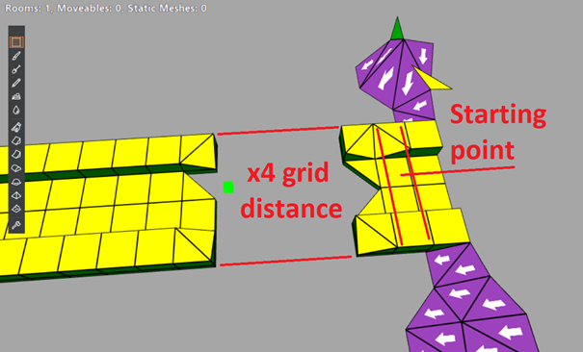

**The idea is pretty simple:**

1. Player goes to the STARTING POINT, which triggers a cutscene (there should be a sudden switch to the cutscene camera, without any black bars or any waiting between gameplay-cutscene).

2. After triggering a cutscene we see Lara walking from the starting point to the CENTRE of the “x4 grid distance” space. There will be an object imitating bridge so the player will think the bridge is intact.

3. While in the centre of x4 grid space the camera starts shaking, Lara tries to maintain balance while looking around confused/scared/angry (probably all). Around her parts of the bridge start collapsing (‘wrath of the beast’ style from TRAOD).

4. In the last moment Lara jumps/rolls back to the STARTING POINT. While doing that the camera switches so both Lara and the bridge are visible. When Lara is safe on the STARTING POINT she looks back (still on the ground/crouching or something) and sees last parts of the bridge disappearing beneath the valley.

5. Lara stands up (and comes back to her initial IDLE position) while the camera returns to her back.

The bridge itself can be made and animated later in development.